EVALUATION FORM – FULL PROPOSALS
  - CLINICAL RESEARCH GROUPS 2022
Proposal Details
Name of the Clinical Research Group
Head

Reviewer Information (Confidential)
Name of Reviewer
Affiliation

Note for reviewers:
- On behalf of the Austrian Federal Ministry of Education, Science and Research (BMBWF) and with additional funds of the Fonds Zukunft Österreich (FZÖ), the Ludwig Boltzmann Gesellschaft (LBG) seeks to fund research projects of high scientific quality as determined by international standards. The selection procedure is based on the specifications of the “Special Guideline: Clinical Research Groups” and the Call Specifications.
- Please provide structured answers with comments under the individual criteria, rather than simply “yes” or “no”.
- Please rate every criterion with a score from 1-6.
Table 1: Evaluation scheme
Score | Explanation | Description
6 | Excellent | The research project meets the criterion very well and fully.
5 | Good | The research project meets the criterion well and to a predominant extent.
4 | Average | The research project meets the criterion in a sufficient manner.
3 | Poor | The research project meets the criterion to an inadequate extent. There are significant weaknesses.
2 | Very poor | The research project addresses/meets the criterion to a very inadequate extent. The weaknesses clearly outweigh the few strengths.
1 | Insufficient | The research project does not meet the criterion.

- Please refer to the focus of the call (see next pages).
- Parts A, B, and C of the assessment will be communicated to the applicant after the funding decision has been made.
- Part D will remain confidential and only accessible to the Scientific Expert Commission and the LBG office. Your identity as reviewer will not be disclosed to the applicants.
Declaration on Confidentiality and Conflict of Interest
- The member of the Scientific Expert Commission will treat all proposals in absolute confidence.
- The member of the Scientific Expert Commission is not permitted to release the names of the other members participating in the evaluation.
- Members exercise their functions impartially and independently.
- The responsibility of the Scientific Expert Commission members consists of participating in the confidential, fair, and unbiased assessment of each and every proposal in accordance with the described procedure and in accordance with the background information for the programme.
- Evaluation is performed solely on the basis of the documents supplied by the LBG relating to the programme and in accordance with the criteria specified.
- A member of the Scientific Expert Commission must inform the LBG immediately of any close relationship to a Clinical Research Group (CRG) or a CRG partner proposing a research project, especially when this relationship may be of a nature to influence or cast doubt on their impartiality as member of the Scientific Expert Commission.
- A member of the Scientific Expert Commission may neither make contact with the applicants nor inform any person not involved in the selection procedure of the recommendation they, or any other Scientific Expert Commission member, has made.
- A member of the Scientific Expert Commission is responsible for ensuring that the documents and data relating to the project are treated confidentially and for ensuring that all documents and data are shredded/destroyed after the completion of the evaluation. The supporting documentation may not be photocopied.
- Members of the Scientific Expert Commission must treat all data relating to applications for funding (particularly the names of the applicants and their company partners, technical data of the research project, etc.) that become known to them as a result of their activities in strict confidence and may not pass them on to any third parties, even in confidence.
- The requirement for confidentiality lasts indefinitely.
By filling out the review and returning it to the LBG office, I hereby declare that I have no conflicts of interest and confirm that I will keep all received material/information confidential.

CALL DETAILS – CLINICAL RESEARCH GROUPS
This first call for proposals for Ludwig Boltzmann Gesellschaft (LBG) Clinical Research Groups (CRG) aims to support larger collaborative research projects with a strong focus on patient-oriented, medically important topics that are scheduled over a medium period (4+4 years). The focus of the funding is on academic clinical research topics – i.e. investigator-driven clinical studies or translational research projects. Key to CRG is thus to strengthen clinical research in general, and to enable more efficient translation of basic research into clinical research and medical innovations. CRG are funded by the Austrian Ministry of Education, Science and Research (BMBWF) as well as the Fonds Zukunft Österreich (FZÖ) and aim to enhance clinical research and help overcome barriers in the processes from bench to bedside.
Table 2: Checklist formal check
Criterion | Requirements checked | Correctable? | Consequence
Completeness of the application | The short or full proposal form must be completed in full; alteration and addition of chapters or headings are not permitted (upload as PDF file) | No | Rejection as result of formal check
Use of correct forms | Short or full proposal form (available at https://lbg.ac.at/kfg/) | No | Rejection as result of formal check
Duration | 4+4 years (indicated by proposed start and end date; second funding period after successful interim evaluation) | No | Rejection as result of formal check
Language | English | No | Rejection as result of formal check
The applicant is eligible for submission of a proposal | Austrian medical university/faculty with an affiliated university hospital | No | Rejection as result of formal check
The Cooperation Partners are eligible for participation | One or more of the following Austrian institutions:  - Public universities  - Private universities  - Universities of applied sciences  - Hospitals (“Krankenanstalten”)  - (Non-profit) non-university research institutions | No | Rejection as result of formal check
Requirements for consortium/staff | - Lead Institution  - Consortia partner(s) institution(s) that are independent from each other  - Mentor and Head must be employed at the Lead Institution  - Min. 5 and max. 15 directly funded researchers (FTE) in total  - At least 1/3 of all Heads are female (including the Head, the Deputy Head(s), and the Work Package/Sub-Project Leader(s)) | No | Rejection as result of formal check
Funding amount | Maximum funding for the first funding period is 4 million EUR | No | Rejection as result of formal check
Attachments to proposal form | Mandatory CVs of the Mentor, Head and of the Work Package/Sub-Project Leader(s) attached using the template and not exceeding the four-page limit | Yes | Rectification via online submission tool is possible
FUNDING:
The total budget for this call is 24 million EUR. Thus, a minimum of three CRG can be funded with an annual budget of up to 1 million EUR for up to 8 years (two potential funding periods of 4 years with interim evaluation). Funding covers personnel, non-personnel expenses and 25% overhead costs on direct eligible costs. Participating institutions must contribute minimum 10% of the total costs of the CRG in-kind.
EVALUATION PROCESS:
This is a two-stage call.
Figure 1: Evaluation process in a nutshell
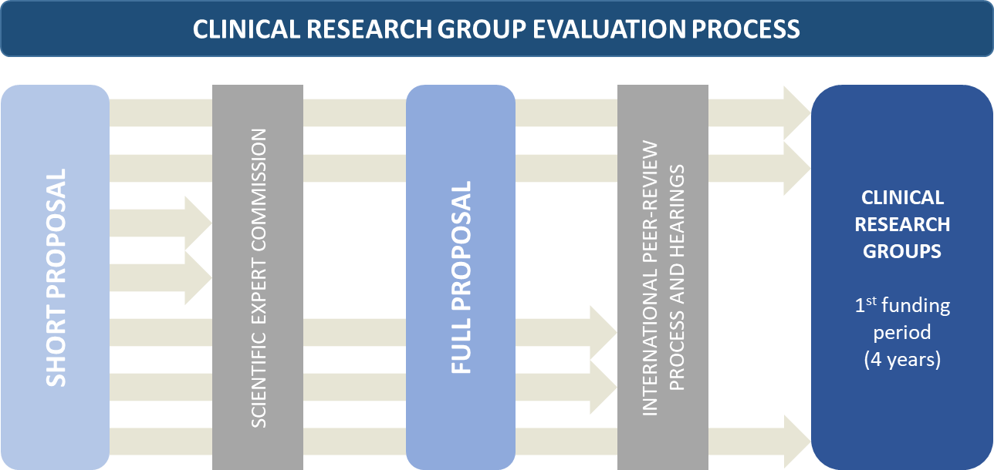

- Short proposals were submitted by 17 November 2022. Full proposals had to be submitted (upon invitation only) by 20 April 2023.
- The process up to now: A Scientific Expert Commission consisting of nine international experts, chaired by Professor Liselotte Højgaard, have pre-selected short proposals of high quality and innovation that met the focus of the call. From 44 short proposals, 8 applicants were invited to submit a full proposal.
- Present step: External review of full proposals in an international peer review process. At least three experts from abroad (outside of Austria) will provide written reviews.
- Applicants from the full-proposal stage will be invited to present their proposal to the Scientific Expert Commission in July 2023. All proposals will be evaluated comprehensively in a jury meeting in Vienna based on the written peer reviews and the Scientific Expert Commission’s own expertise, resulting in a recommendation “to be funded” or “not to be funded” for each proposal.
- The assessment process (peer review and Scientific Expert Commission meeting) will culminate in a formal funding decision made by the Federal Minister of Education, Science and Research for funds allocated by the BMBWF (according to the “Special Guideline: Clinical Research Groups”, section 8.7), and by the LBG’s board of directors for funds allocated by the FZÖ (in accordance with the regulations of the FZÖ). The decision is expected in July 2023.
SCOPE:
Proposals must include the description of the planned research project as well as a description of the work packages/sub-projects that are planned to be conducted by the CRG. The research project including its work packages/sub-projects must meet the following criteria:
- A coherent research project must be presented in the proposal, describing how individual work packages/sub-projects form a larger project, and thereby create benefit.
- Research projects must be innovative and of high quality in the field of disease and patient-oriented research.
- The number of work packages/sub-projects has to be justified depending on the nature and content of the research project. However, more than 50% of the proposed work packages/sub-projects must be carried out at medical universities/faculties.
- Work packages/sub-projects shall include development and/or improvement of diagnostic and/or therapeutic methods, and produce new medical knowledge and innovation for the benefit of patients’ health.
- Research projects should address in particular investigator-initiated clinical trials (eligible are phase I to phase III) or other non-commercial clinical studies in combination with clinical pilot or accompanying studies (observational studies, longitudinal studies, epidemiological studies, biobanking, biomarker studies, patient outcome studies, proof of concept studies, etc.) that are integrated into a research project. The project shall be led by academic research questions.
- Research projects must meet the standards of good clinical practice, i.e. key principles such as adherence to ethical principles, risk minimisation, subject’s rights, safety and well-being, adequate drug information, scientifically sound protocols, IRB/IEC review and approval, protocol adherence, involvement of qualified physicians, etc. They thus contain a sound study design with descriptions of i.e. the research approach, purpose of the trial/study, study protocol, randomisation, statistical power, etc.
- The research project teams shall be interdisciplinary and demonstrate a synergistic collaborative attitude between clinical and non-clinical team members (see section3.3 of the Call Specifications).
- Proposals must include a plan to promote career development of young researchers/clinicians and address gender equality issues both within teams as well as in the research project.
- A description of the planned mentoring concept has to be included. This must contain a description of intended measures (training, qualification, supervision). Innovative and new methodological approaches are preferred.
For more details, please see the Call Specifications.

Scientific excellence of the proposal and fit to the call
Fit to the scope, relevance, potential
- Describe whether and how you see the proposed research project advancing the field of Clinical Research (i.e. with a potential for future applications).
- Does the research project provide a substantial contribution to the scope of the call?
- Is the state of the art/knowledge of the relevant scientific field known by the applicants and is it considered?
- Comment on the innovative nature and potential for progress with regard to the state of the art.
- Does the research project imply leverage or signal effects?

Excellence, innovativeness, originality
- Please describe why the proposed research project is (or is not) at the forefront of international research.
- Please comment on whether the research question(s), objectives and hypothesis are well framed.
- How novel are the proposed methodologies and approaches for answering the research question(s)?
- Does the used methodology fit the scientific profundity of the research project?
- Have the applicants considered innovative and appropriate use of methods/technologies, patient cohorts, and data?
- Is the description of the research project sufficiently specified with regard to the CRG goals?
- What concrete results are expected at the end of the CRG, are they comprehensible?

Please comment on the clinical relevance of the proposed research project, and its potential to lead to improved diagnosis or prognosis of human diseases, or to therapeutic strategies.

Competencies of applicants
Please comment
- Are the participating institutions and their personnel qualified; are their personnel capacities and their device-related equipment adequate to conduct the research project successfully?
- Please evaluate the CRG staff’s experience and track record, taking into consideration the number of years in an academic position and any career breaks.
- Collaboration/interdisciplinary aspects: Do the field of research activities and qualifications of the participants complete each other in order to ensure a constructive and efficient handling of the CRG?
- Team composition: Describe if and why the competencies of the CRG team are sufficient and complementary for the proposed research project with consideration to project management and furthering career development.
- Does the project management seem adequately qualified to carry out the research project?
- Please also comment on the gender balance in the team.
- Are the roles of the Mentor as well as of the Head well elaborated?

Quality of planning
Research design, methods
- Is the description of the research project design sufficiently specified with regard to the CRG goals?
- What concrete results are expected at the end of the CRG, are they comprehensible?
- Are the work packages/sub-projects reasonably structured, are there any verifiable milestones?
- Does the planned period seem adequate to conduct and accomplish the tasks?
- Are the starting point, the goals, the necessary measures, and steps to conduct the research project clearly and consistently defined?
- Are the work packages/sub-projects appropriately selected in terms of number and content, and are relevant experts assigned?
- Handling of development risks?

Good scientific practice, ethical, and legal aspects
- How does the proposed CRG meet the requirements of good scientific practice?
- If applicable, are the proposed cohort or sample sizes sufficient to allow meaningful statistical evaluation?
- Do the applicants intend to undertake appropriate measures for data management? Have the applicants ensured the use of FAIR principles for data use and dissemination of results?

Financial plan/budget
- Are the requested resources and budget (both personnel and non-personnel costs) justified to the planned tasks and the potential results?
- Are there sufficient resources available to the research team to pursue the research project?
- Is the calculation of the costs coherent and comprehensible?
Note: Comments on salaries of researchers are not required as these are defined (mostly) by national standards.

Please summarise your assessment
Strengths:
…
…
…
Weaknesses:
…
…
…

ASSESSMENT OF THE PROPOSAL (CONFIDENTIAL PART OF ASSESSMENT)
6.0 Excellent / 5.0 Good / 4.0 Average / 3.0 Poor / 2.0 Very Poor / 1.0 Insufficient
(subgrades are not possible)

A: Scientific excellence of the proposal and fit to the call:
- Fit to the scope, relevance, potential
- Excellence, innovativeness, originality

B: Competencies of applicants:
- Team composition, collaborative/interdisciplinary aspects, gender aspects
- Career development prospects

C: Quality of planning:
- Research design, methods
- Good scientific practice, ethical, and legal aspects
- Financial plan/budget

D: Overall rating of the proposal:

Any confidential comments to the Scientific Expert Commission/LBG office:

Please state which aspects of the proposal are closest to your expertise:

In well-founded cases, an individual application by a university is also possible. In such cases, greater emphasis should be placed on cooperation between different clinical departments and on interdisciplinarity between researchers.

